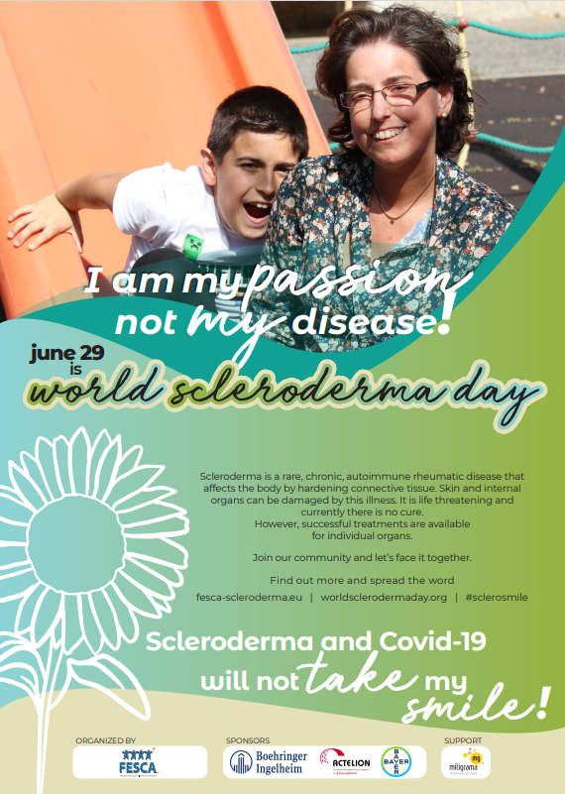

Tânia Vieira - Testimony
My passion... I have so much to share about my passion...❤️
My SON is my passion!
Being a MOTHER gave me the necessary strength to know how to live, and above all how to enjoy life, having the courage and power to overcome the difficulties that the disease brought me.
My son makes me believe that it is still possible to have the hope of a better quality of life, even with the visible sequels that Scleroderma has caused me.
By irony of destiny, or not, both came into my life 10 years ago...my passion and the disease!
Tânia Vieira – 38 Years
Diffuse Scleroderma – Bone Marrow Auto-Transplant in 2019

