I am my passion, not my disease!
The patient’s journey to a diagnosis.
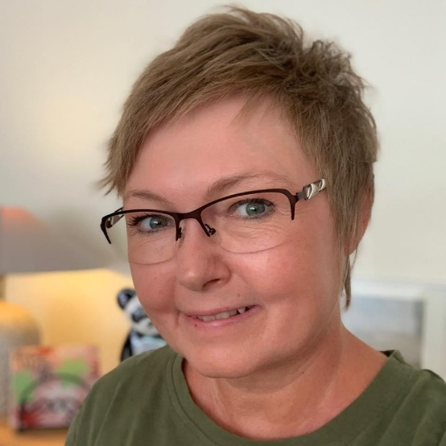

Annelise Roennow – limited cutaneous systemic sclerosis for 14 years.
Getting the right diagnosis when having a rare disease like systemic sclerosis can be long and sometimes it feels like going through a maze to find the answers – once you feel like you are close to the answer you end up at a dead road and have to go back and find another way through the maze.
Many have symptoms for years and no one can tell you what is happening. The symptoms can be diffused, and the primary care physician cannot tell you what is going on but might give you treatment for the Raynaud’s phenomenon as Raynaud’s is not rare as such. That was the start of my journey through the maze, and I think it took 5 years before I got my diagnosis, limited cutaneous systemic sclerosis. But it was in fact fast, because when the next strange symptoms emerged and my primary care physician found a specialist to send me to, it took me 4 weeks. My theory is that I (by coincidence) was sent to a specialist who knows a lot about different kinds of connective tissue diseases, included systemic sclerosis, and she knew what blood tests to run and what to look for.
The patient’s journey to the diagnosis can for some be fast track through the maze but I have seen many cases where the journey is back and forth in many different directions. No matter what symptoms you have, you go to your primary doctor. He might not recognize the symptoms or say, “let’s see what happens”. Then most of us do online research on our symptoms – it is so easy nowadays to look up symptoms and you get a result. But I cannot recommend you do an online search whether it is for symptoms or after you are newly diagnosed. You might find the wrong answer or find stories that are very scary. After some time, you return to your primary doctor. You are now being referred to a specialist, who might not recognize the symptoms fully and you get referred to another specialist, who does not give you a diagnosis, or your are being misdiagnosed and get the wrong treatment. Eventually you get the diagnosis.
A diagnosis, no matter what diagnosis, can be bad news but also good news. For most of us, the diagnosis is a relief. Now we can team up with others just like us, and the best teams are via the patient organizations. We can start a treatment; we are ready to fight back.
For me the diagnosis was a relief. I knew I wasn’t making my symptoms up. I was recognized. My chosen path in life was changed and after some years I accepted this and found another path. I fought back!
Despite the differences in the disease, I see the same things, when talking to fellow patients. We all have this special drive, some more than others, but behind the pain and struggles I see the sparkle in the eyes. We all have this passion saying that we are so much more than our disease. Whether our passions are skydiving, rollerblades, knitting, reading, painting, traveling, cooking, being a mother and so on – we prove repeatedly, that we are our passion, not our disease!

