**I am my passion, not my disease!**

**The importance of Patient Associations**

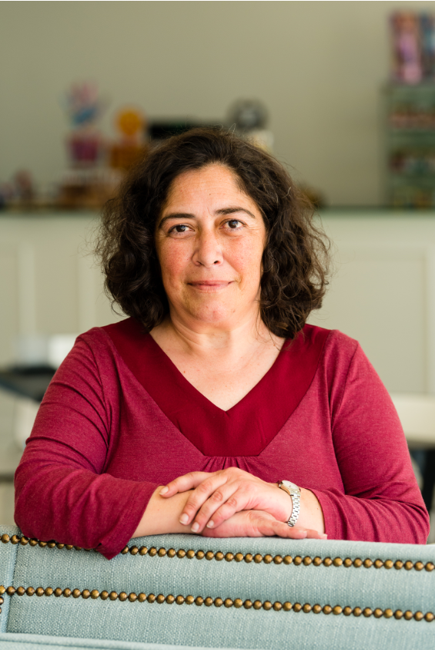

***Elsa Mateus - President of the Portuguese League Against Rheumatic Diseases***

Taking on the leadership of an association that represents people with disease, in a context in which the experience of living with the disease is fundamental in understanding the problems and needs of the community we represent, necessarily implied public exposure as a "patient".

Those who live with a chronic disease know this dilemma well: we are much more than the disease we have! It is always difficult to balance the negative impact that illness has on our lives with the positive message that, despite this, it is possible to live our passions, often shaped in that dialogue between dreams and circumstances, between limitations and precautions.

In the course of my duties, I was asked one day what it was like to live a daily life centred on illness. I could not answer, because I never looked at it that way. More than the illnesses themselves, we are concerned with people and their passions. The action of an association like the League is not so much focused on the disease itself, but on the various ways of reducing its impact on the lives of those affected by it, advocating for access to healthcare and treatment, for social inclusion and employment, for social protection in disability, for well-being and quality of life and, above all, for access to information.

That is our role, our passion. Only by focusing our actions on support, education, awareness, advocacy, cooperation and research will we be able to help patients to be understood, and to understand themselves, as people with illness and with a whole life beyond it.

Therefore, and for this reason, it is necessary to show others that although we have a chronic rheumatic disease, it does not define us as people. Despite the impact it has, we are able to live without the need for compassion, because of the resilience we have acquired and that should be more valued.

In the League, we value the experience of living with the disease by transforming it into support for other people diagnosed, into information to alert policy makers to the existing problems, into contributions to research focused on the needs of patients.

This has been one of the lessons I have learnt since I joined the association. My experience of living with the disease counts, it is important for others to know more about the disease, about the impact it can have and ways to reduce it, so that we can live full citizenship and our passions. It is in this spirit of sharing that, as an association representing all rheumatic diseases, we are able to understand the common problems and the specificities of each one, as is the case with Scleroderma.

So that in the eyes of others we are more than the disease we have, we need to show that we are much more than the disease, and that despite the difficulties it puts us through, or even because of it, we are capable of living several passions and achievements. The Scleroderma Patients’ Group of the League inspires us a lot in this sense!